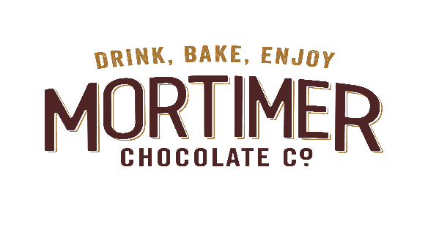
www.mortimerchocolate.co.uk
To order by post please print and send your completed form to:
Mortimer Chocolate Company Ltd, 66 Windmill Road, Mortimer Common, Berkshire, RG7 3RL

Please Complete in Capital Letters
Your Details |  |  |  |  |  | If you would like to send this delivery as a gift to an address different to the one shown, please write the delivery address here.
Name | …………………………………………………. |  |  |  |  | Name | ………………………………………………….
Address | …………………………………………………. |  |  |  |  | Address | ………………………………………………….
………………………………………………………………. |  |  |  |  |  | ……………………………………………………………….
………………………………………………………………. |  |  |  |  |  | ……………………………………………………………….
Town…………………………Postcode………………….. |  |  |  |  |  | Town…………………………Postcode…………………..
Tel.(inc code)……………………………………(in case of query)
If you require delivery outside of the UK, or have any questions regarding ordering, please call  01189332073 Mon-Fri 8am-6pm |  |  |  |  |  | If you would like to include a message with your gift, please add it here:
To sign up for free recipes, please add your e-mail address here: |  |  |  |  |  | ………………………………………………………………
……………………………………………………………… |  |  |  |  |  | ………………………………………………………………
 |  |  |  |  |  | ………………………………………………………………
 |  |  |  |  |  | ………………………………………………………………
Product Description |  |  |  | Number of |  | Pack Price |  | Total Price
 |  |  |  | Packs
West African 70% Chocolate 250g |  |  |  |  |  | £4.99
Ecuador 70% Chocolate 250g |  |  |  |  |  | £4.99
White Couverture Powder 250g |  |  |  |  |  | £4.99
West African 30% Drinking Chocolate 250g |  |  |  |  |  | £3.65
Please add Postage and Packing (UK only): |  |  |  |  |  |  | Total
P&P £2.85 for orders up to £27, £5 for orders over £27.  Orders over £75 are free delivery |  |  |  |  |  | Postage and Packing
 |  |  |  |  |  | Total Payable
 |  |  |  | £……….. |  | Please make cheques and postal orders out to:
I enclose my cheque/postal order for |  |  |  |  |  | Mortimer Chocolate Company and add your name
 |  |  |  |  |  | and address to the back of the cheque.

Thank you very much for your order, we hope that you enjoy the chocolate!

