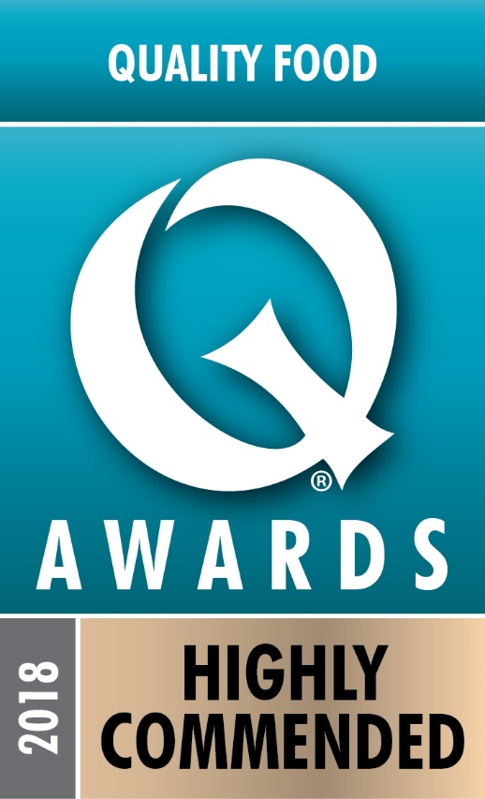

Recognising Excellence in Product Development
6th November 2018
Mortimer Chocolate Beats the Big Boys!
The Family-run Berkshire business, Mortimer Chocolate Company is celebrating after beating multi-national competition to win a “Highly Commended” in the 2018 Quality Food Awards!

The company received its award in the hot beverage category for its Salted Caramel Chocolate Drink, following a blind tasting by industry experts. The awards, which are to recognise excellent new product development, are dominated by big business, with their large R&D budgets. Adrian Smith, managing director of Mortimer Chocolate said: “It is great to beat such tough opposition as Aldi and Typhoo. We have a tiny budget, but we aim to get our drinks just how our customers like them and this award shows us that we’ve done just that!”

Mortimer Chocolate Company is a small, UK chocolate producer, that specialises in producing chocolate drinks, available on-line through Amazon, in local outlets through the Thames Valley and in cafes across the country.
“It is our attention to the flavour of the drink and the quality of the cocoas that we use that makes our chocolates stand out,” adds Adrian. “Our customers are always telling us how much they love our products and this award reinforces that!”

-ENDS-

Notes to Editors:
1). Mortimer Chocolate Products are available on Amazon.
2). Mortimer Chocolate specialise in chocolate drinks, also making the Harrods range of Drinking Chocolates.
3). Mortimer Chocolate was founded in 2006 by husband and wife team Adrian and Felicity Smith. Adrian spent 20 years at Mars, where he was responsible for sourcing cocoa and also for taking Galaxy and Maltesers into the hot drinks category. Adrian sources the cocoa and makes the chocolate for Mortimer Chocolate Co.. Felicity is a qualified nutritionist and is the creator of many of the flavoured drinks.
4). For further information visit: www.mortimerchocolate.co.uk

Contact Details:
Mortimer Chocolate Company:
adrian.smith@mortimerchocolate.co.uk
Telephone: 0118 9332073 / 077 1000 6628

